Sprint 4 Testing Report

* The website was tested using Testing Whiz.

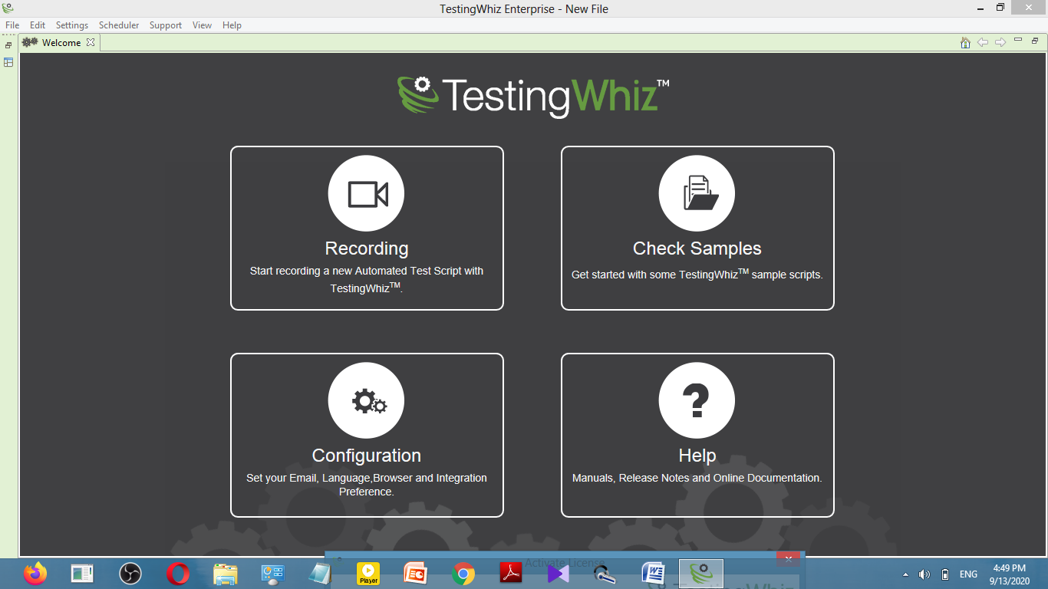

* The header and footer have been created according to the UI.

But in the UI the header also has a link for paying fees that was not implanted in the header of the website.

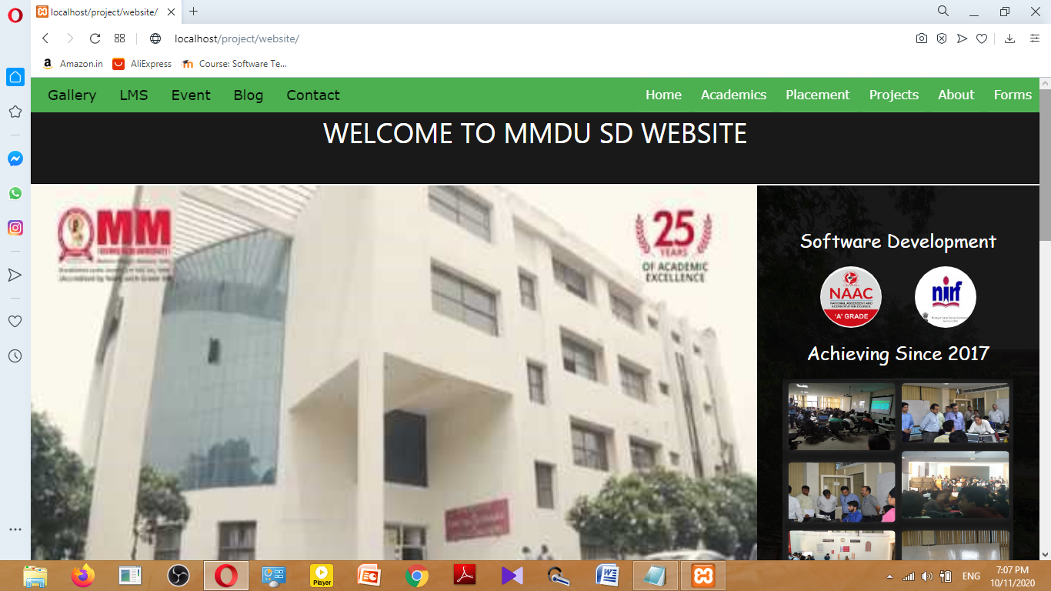

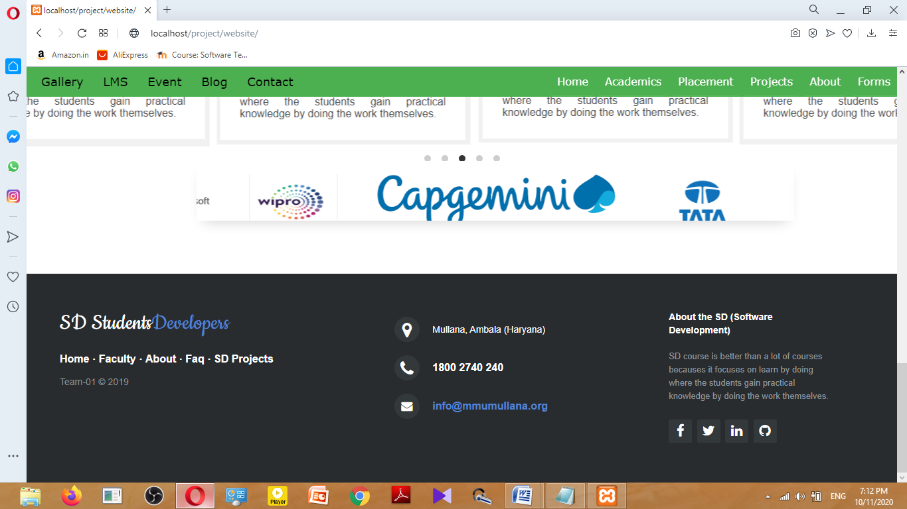

* Some of the links in the header like Laptop, Placement, Developers, Placement, Blog and Contact are also not working as they will be implanted in future sprints
* The homepage of the website has been created according to the UI. It also has a slideshow of testimonials and slideshow of company logos.



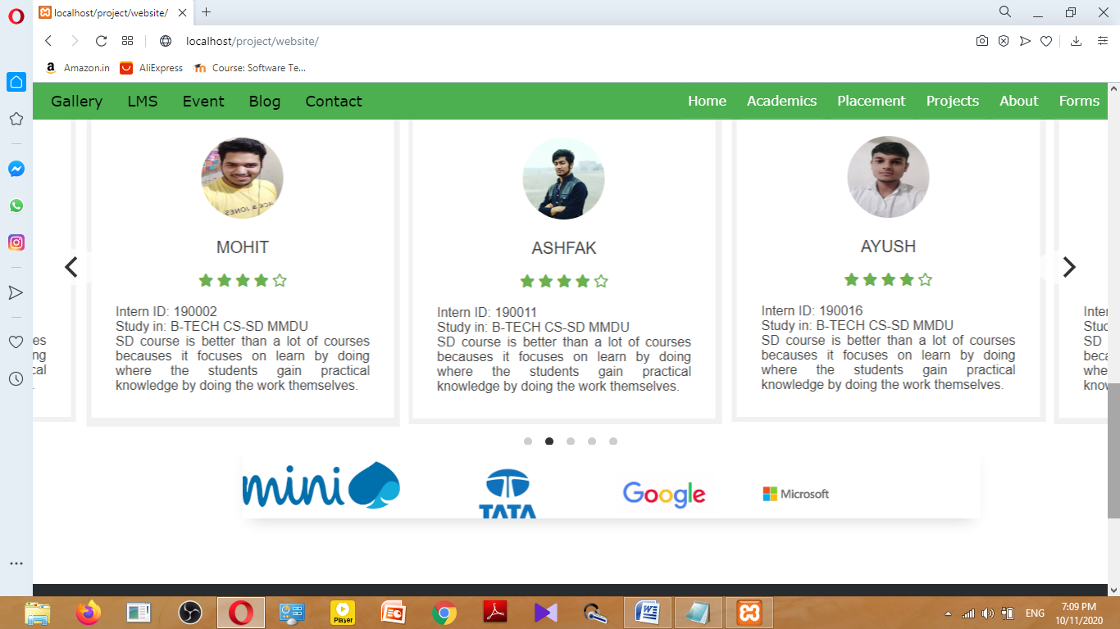

* The Gallery webpage has been created according to the UI. The photo also enlarges on clicking on it.

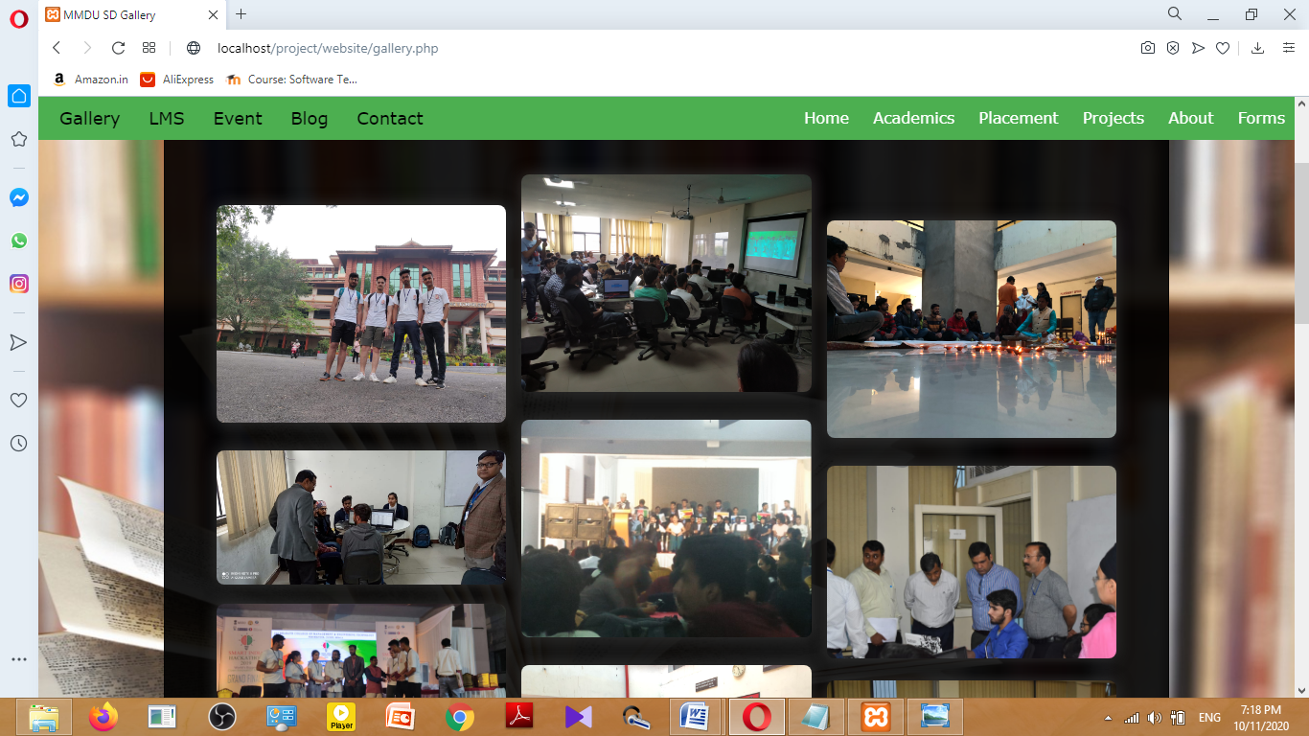

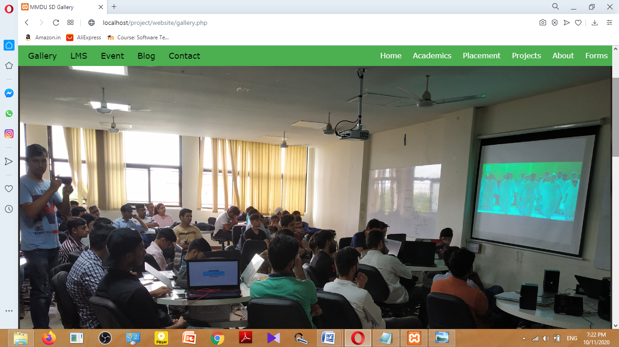

* A link for LMS has also been added in the header.

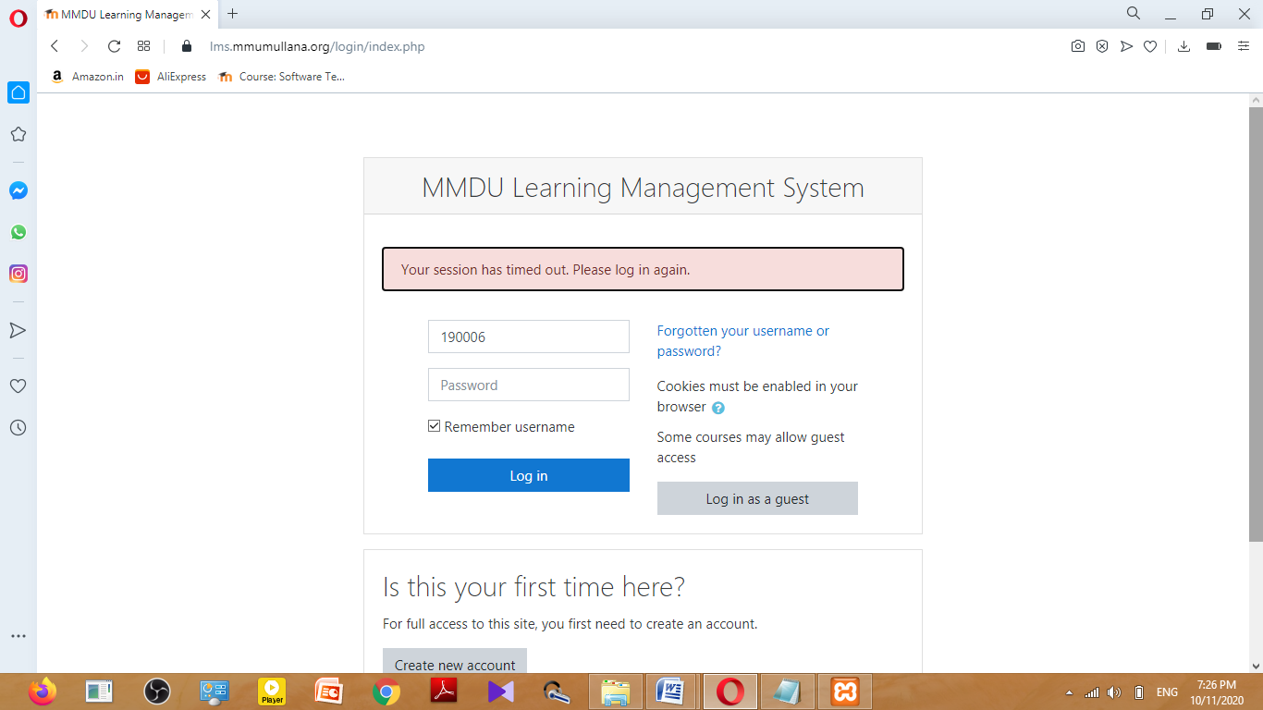

* The event webpage has been created according to the UI and a calendar has been added.

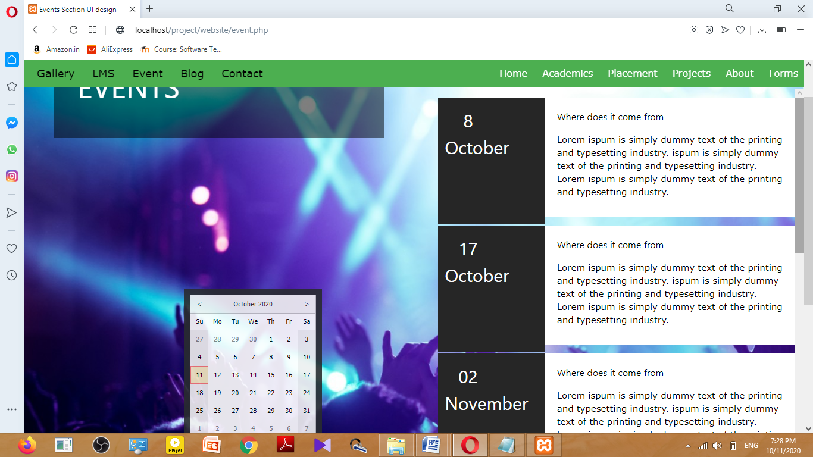

* The course webpage has been created according to the UI. It has information about SD and information about the subjects in tabular format using details and summary tag.



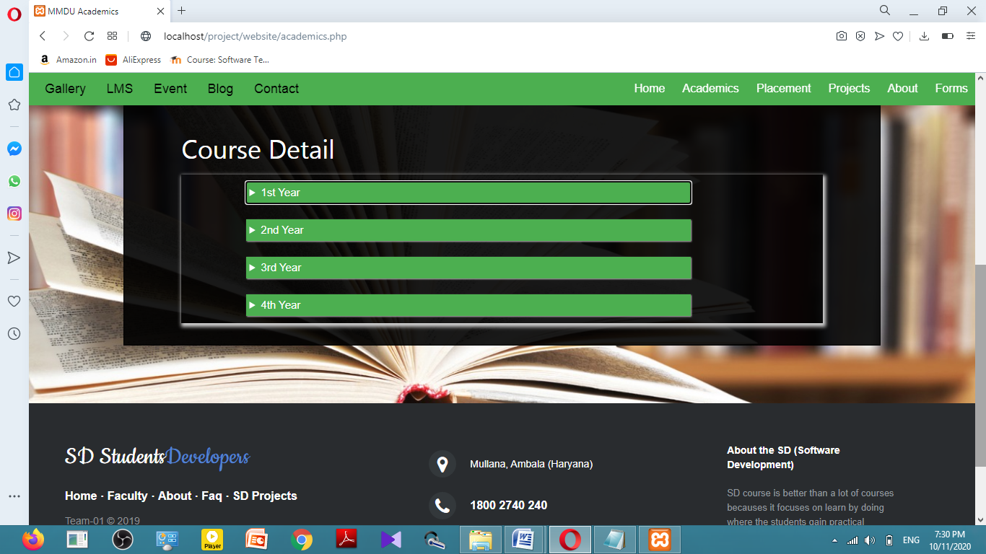

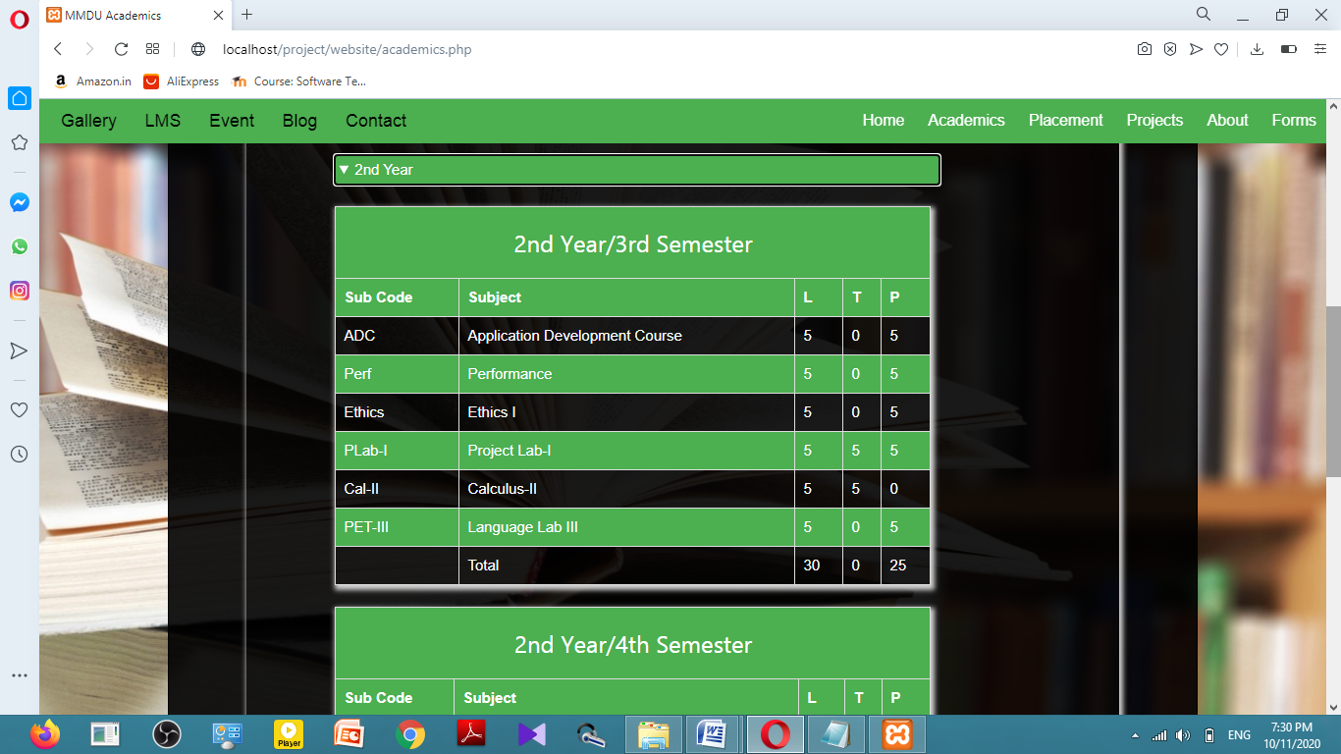

* The Grading webpage has been created according to the UI. The grading system is properly explained and calculator has been added as well.

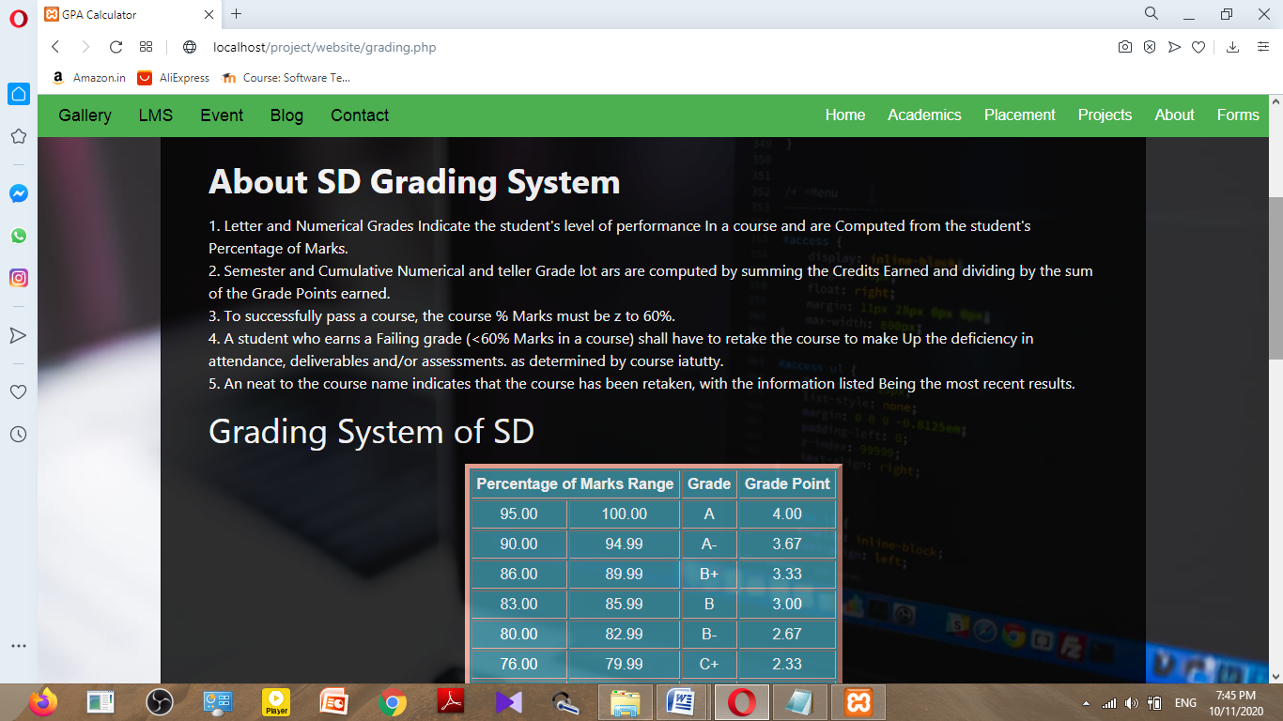

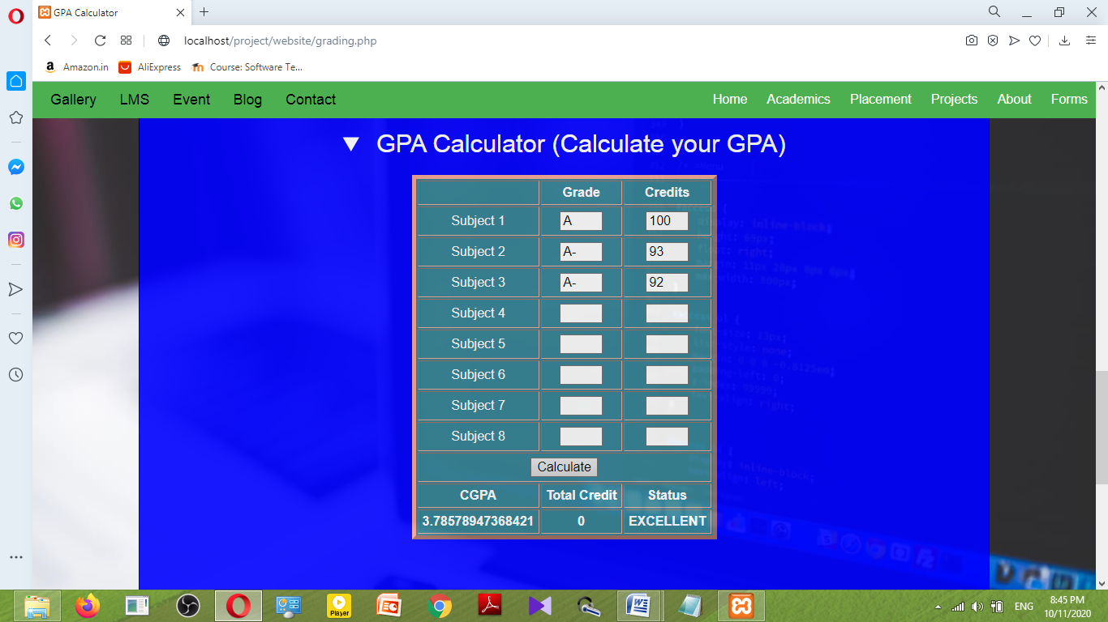

* The SD projects website has been created according to the UI and has videos of project with their details.

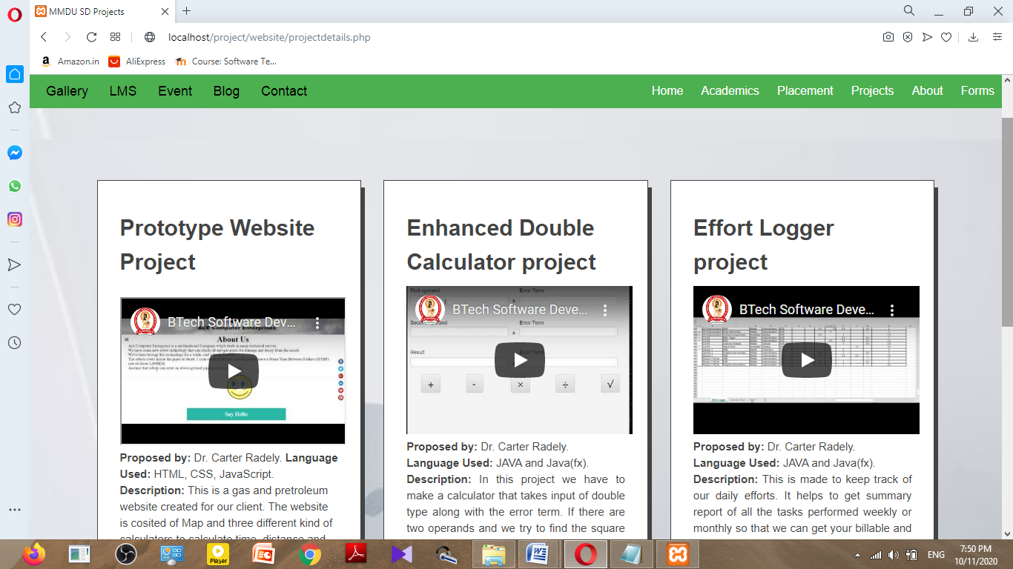

* The FAQ webpage has been created according to the UI. Various Questions have been added using details and summary tag.

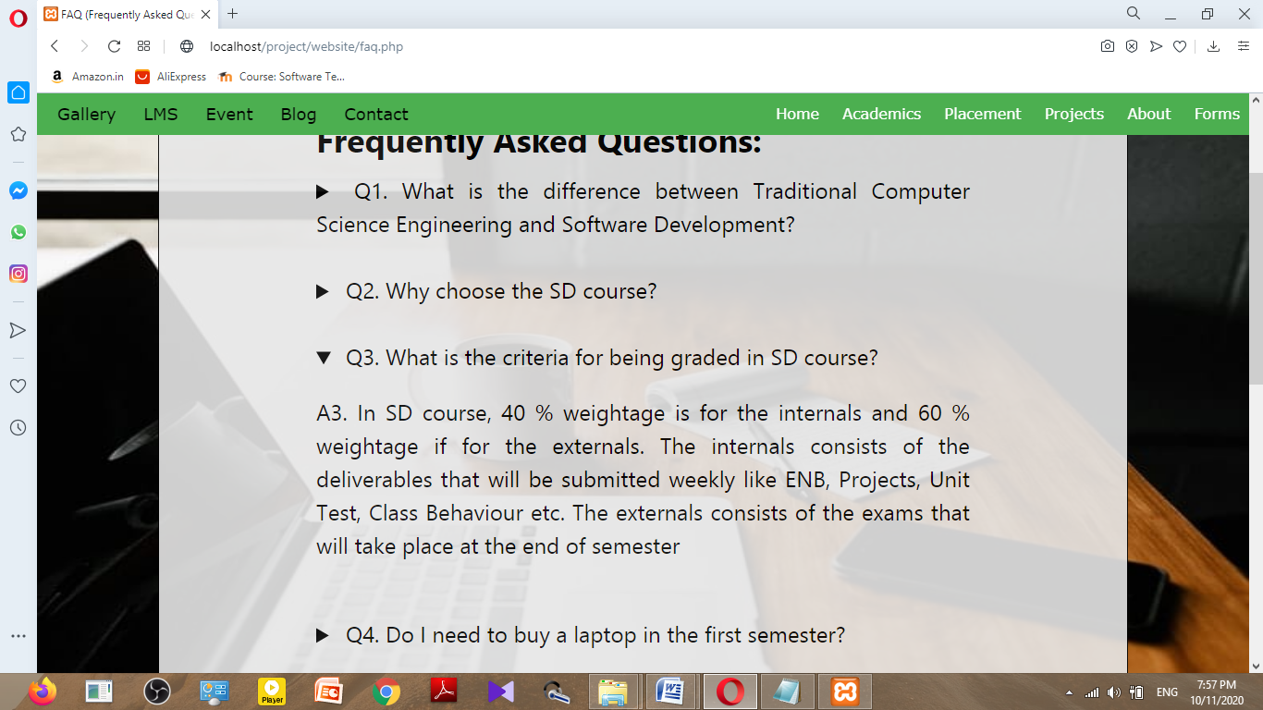

* The SD Faculty webpage has also been created according to the UI. It also has a form for asking for appointment which shows error if required fields are not filled.

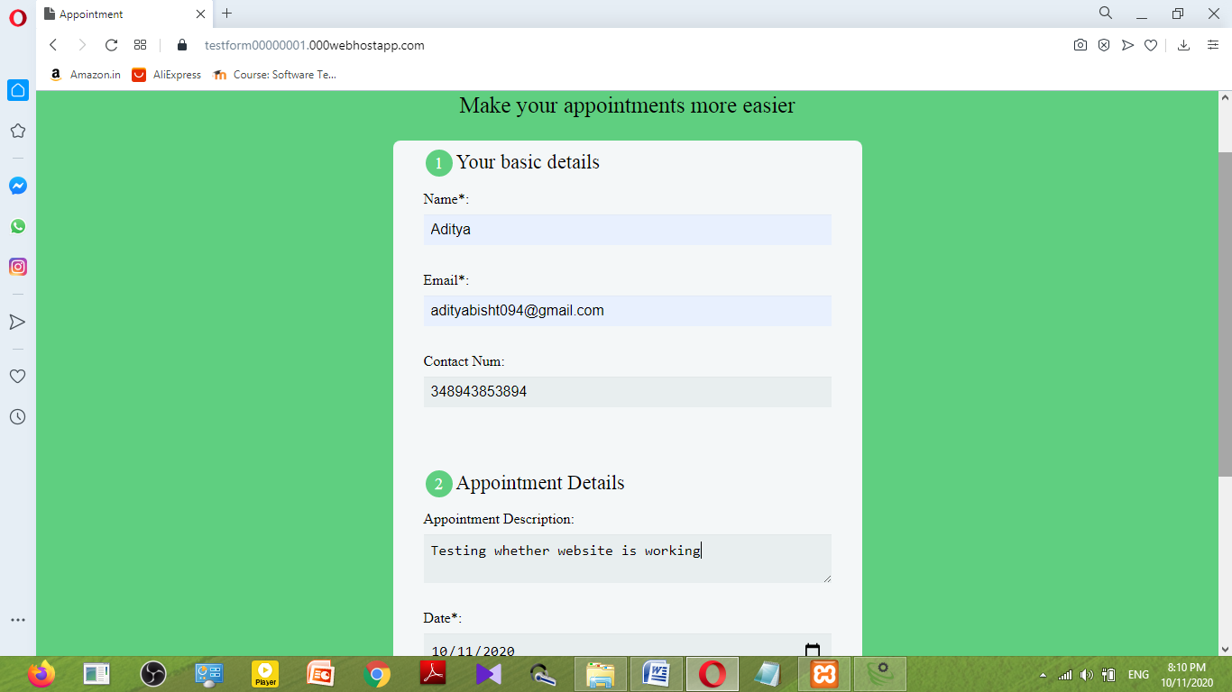

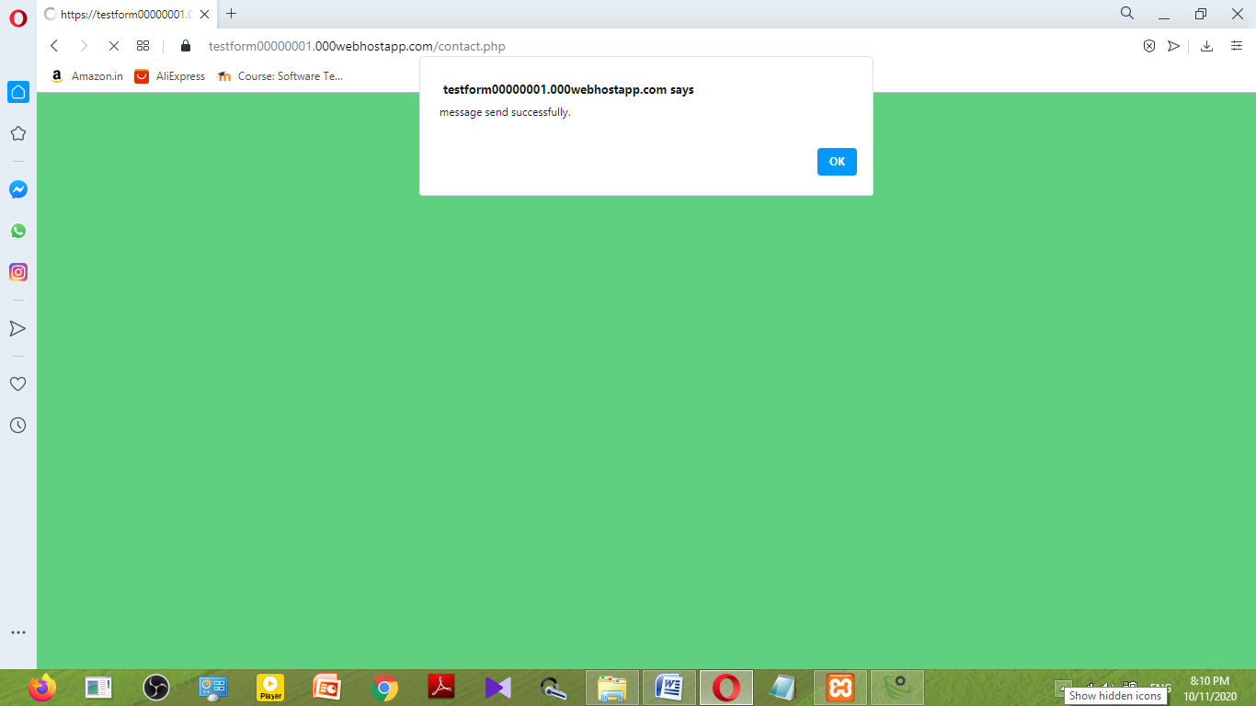

* Forms for Event hosting, Query and Feedback have been created which show error message if required fields are not filled.

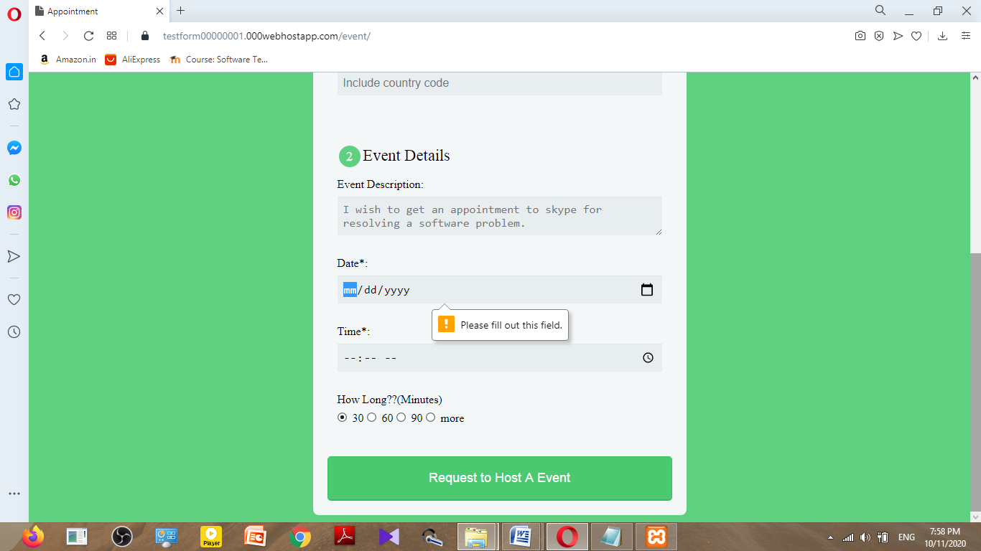

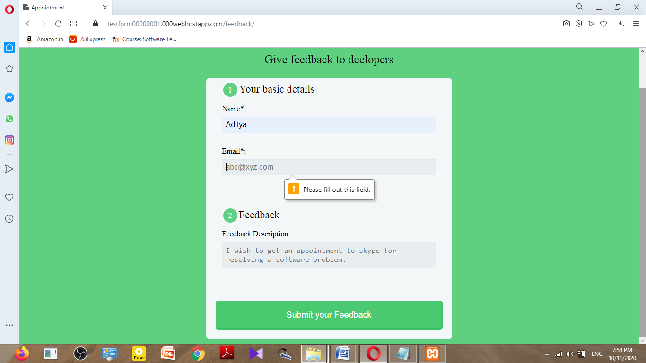

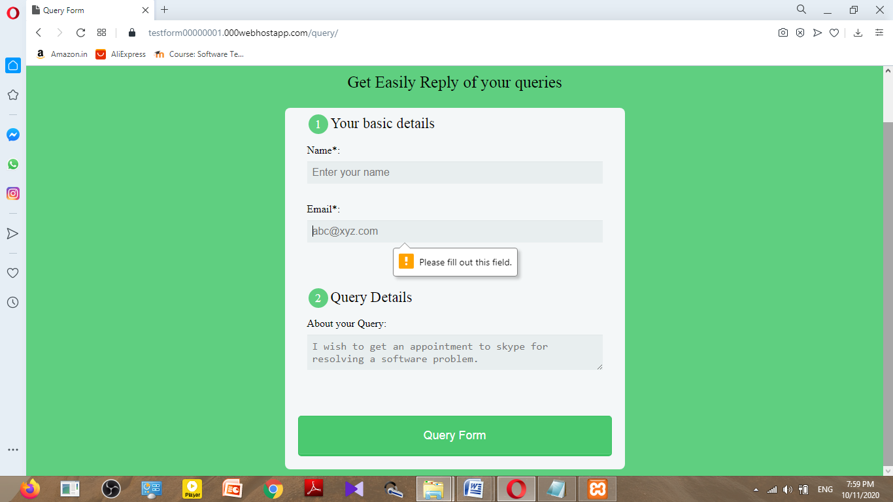

Testing Report:

